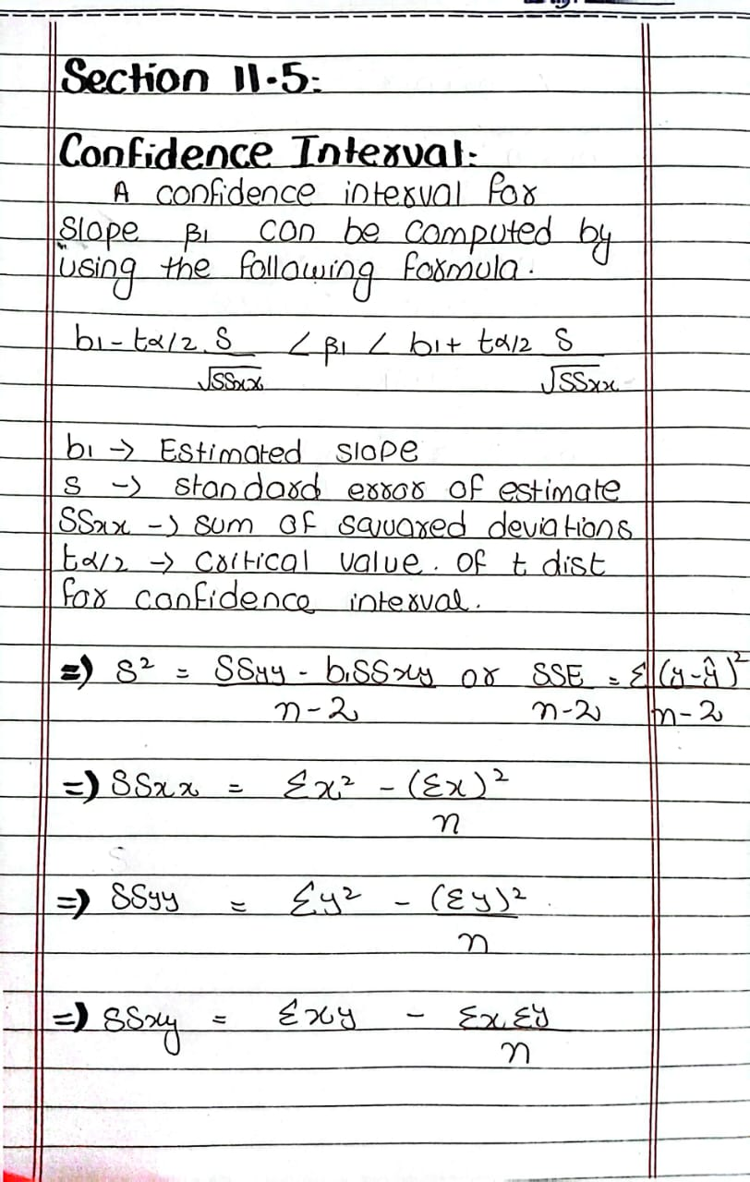
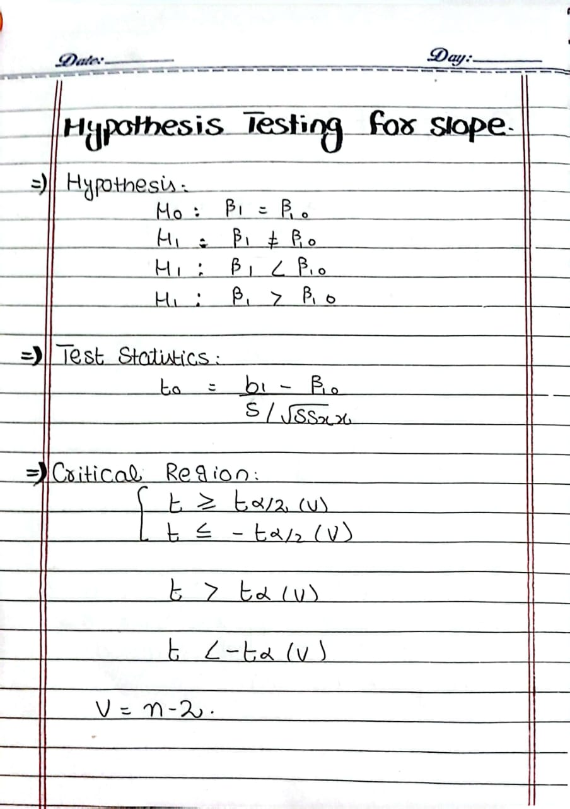
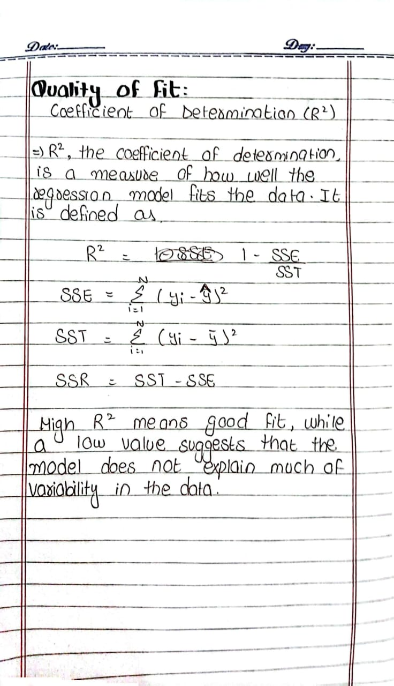

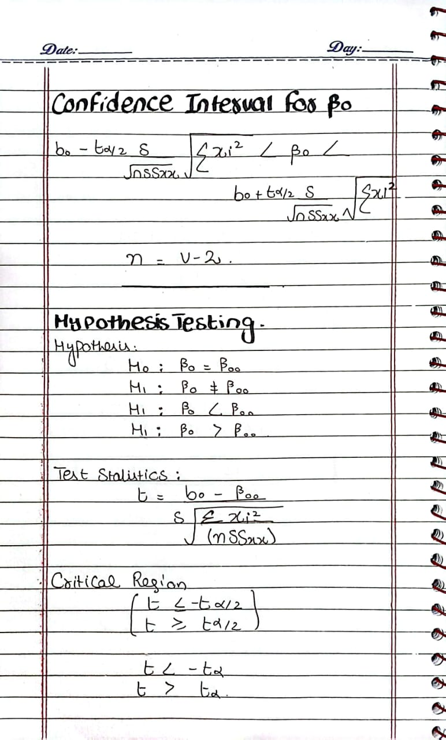
Question 1:
Find a 95% confidence interval for β1 in the regression line μY|x = β0+β1x, based on the pollution data of Table 11.1.
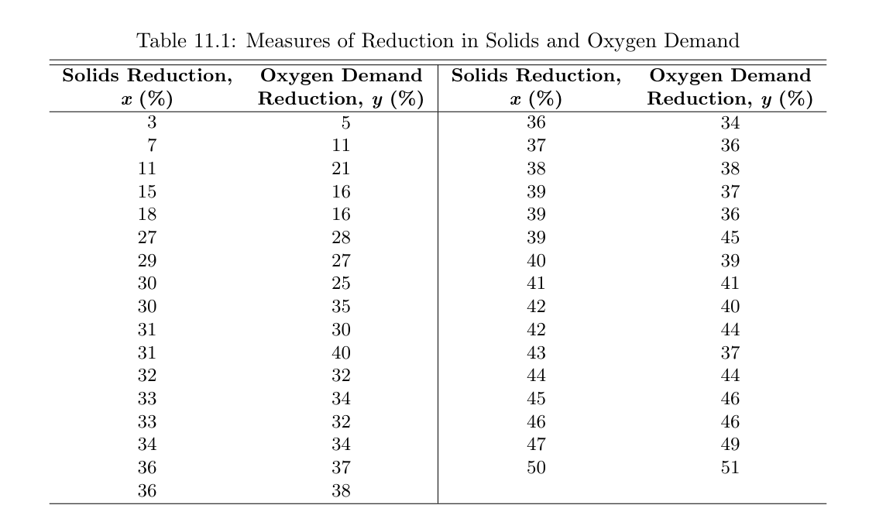
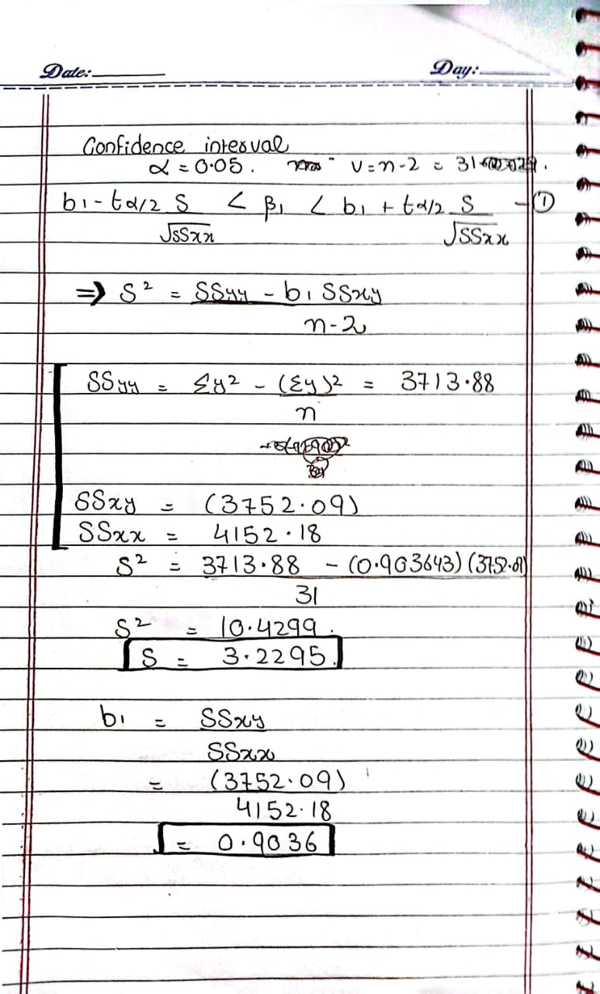
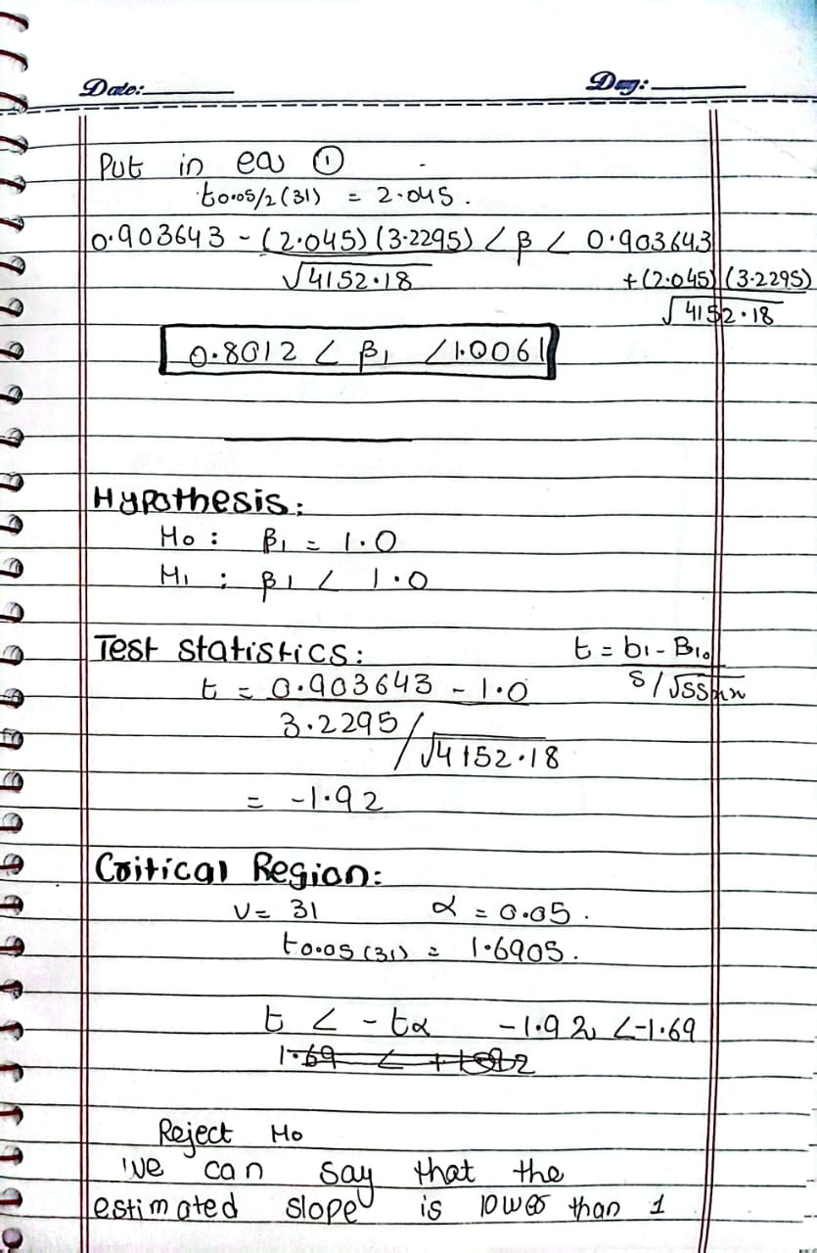

Question 2:
Using the estimated value b1 =0.903643 of Question 1, test the hypothesis that β1 =1.0 against the alternative that β1 < 1.0. With 95% confidence interval

Question 3:
Find a 95% confidence interval for β0 in the regression line μY|x=β0+β1x, based on the data of question 1
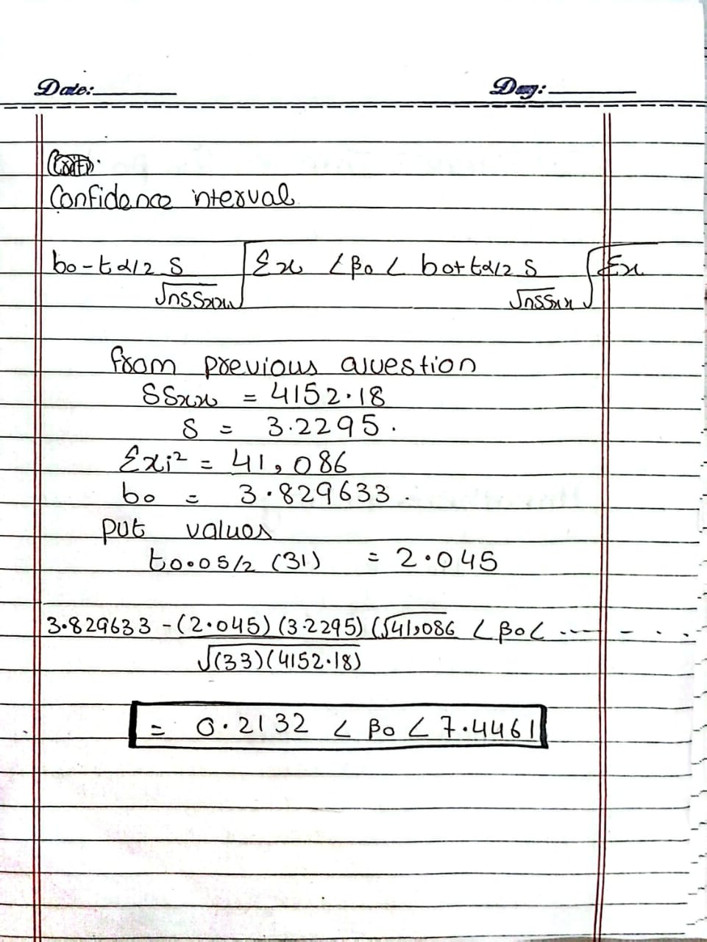

Question 4: Using the estimated value b0 =3.829633 of question 1, test the hypothesis that β0 = 0 at the 0.05 level of significance against the alternative that β0=0.
